

**UNIVERSITY OF PETROLEUM & ENERGY STUDIES**

**Dehradun**

ACO LAB

**Name-Ritik Kumar**

**Batch- 4 DEVOPS**

**SAP ID- 500097106**

**Roll No- R2142211330**

**SUBMITTED TO- Dr. Hitesh Kumar Sharma**

**EXPERIMENT – 7**

**AIM: Creating Pods in Kubernetes**

Below is a lab exercise that will help you understand and practice creating pods in Kubernetes:

# Task 1: Start Kubernetes in Docker-Desktop

* Start Kubernetes service in Docker-Desktop

# Task 2: Creating a Simple Pod

* Create a simple YAML manifest file named pod.yaml to define a basic Podin Kubernetes. An example of the file content is as follows:

apiVersion: V1 kind: Pod metadata:

name: my-nginx-pod labels:

app: lbnginx spec: containers:

- name: nginx-container

* Apply the Pod configuration using the following command:

# “ kubectl apply -f pod.yaml ”

* Check the status of the Pod using the following command:

# “ kubectl get pods ”

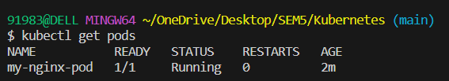

**Task 3: Accessing the Pod**

* Access the Pod by using *port forwarding* to the container. Run the following command:

# “ kubectl port-forward my-nginx-pod 8081:80 ”

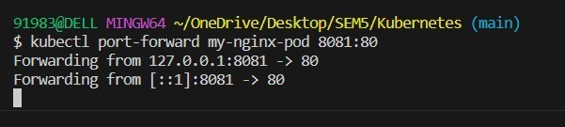

* Access the Nginx server running in the Pod by opening a web browser and navigating to http://localhost:8081

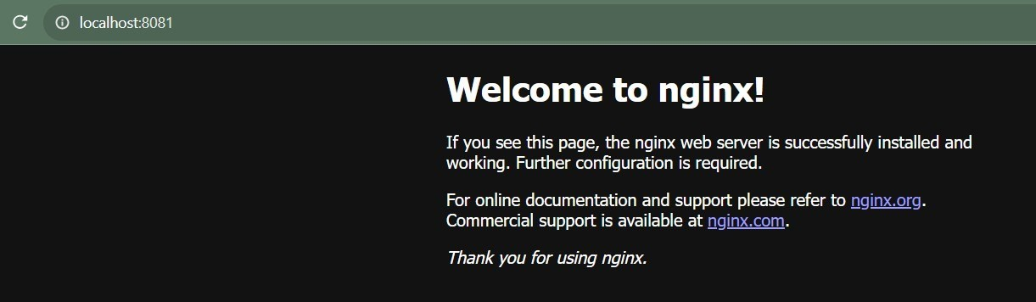

# Task 4: Exploring Pod Details

* Retrieve detailed information about the Pod using the following command:

# “ kubectl describe pod my-nginx-pod ”

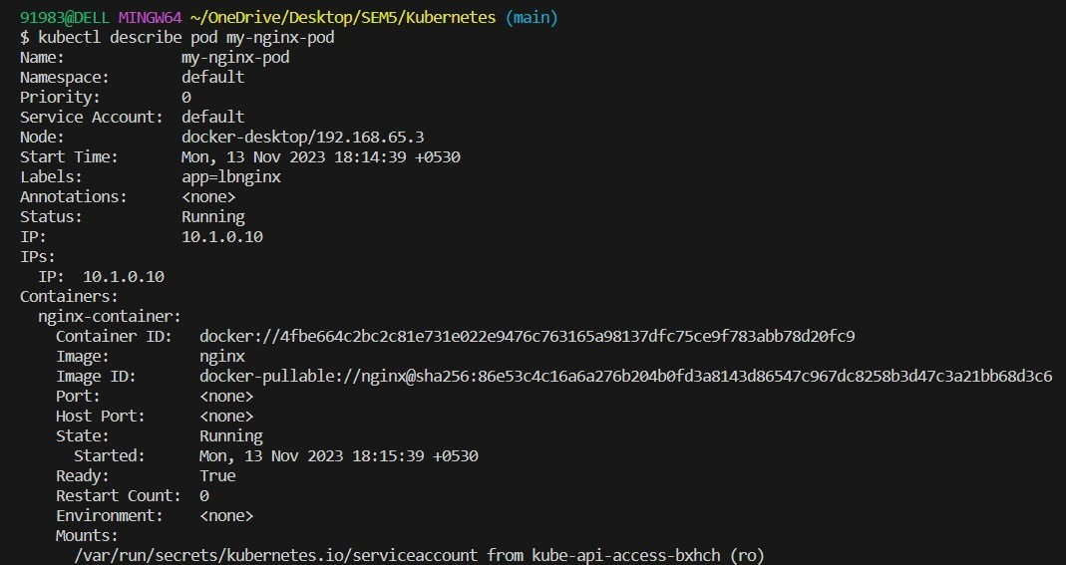

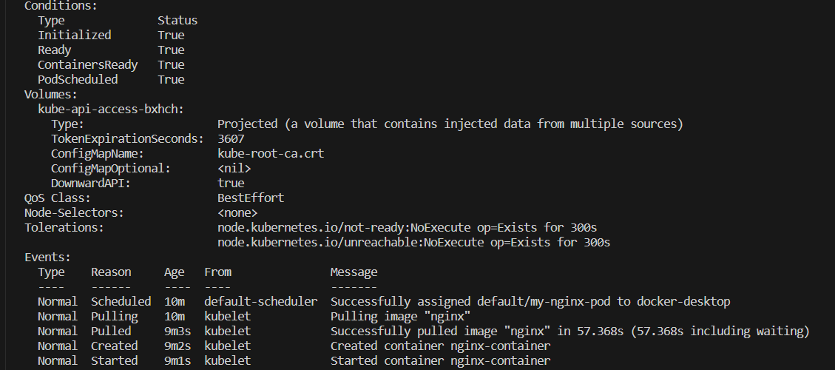

* + Check the logs of the Pod to understand its behavior using the following command:

# “ kubectl logs my-nginx-pod ”

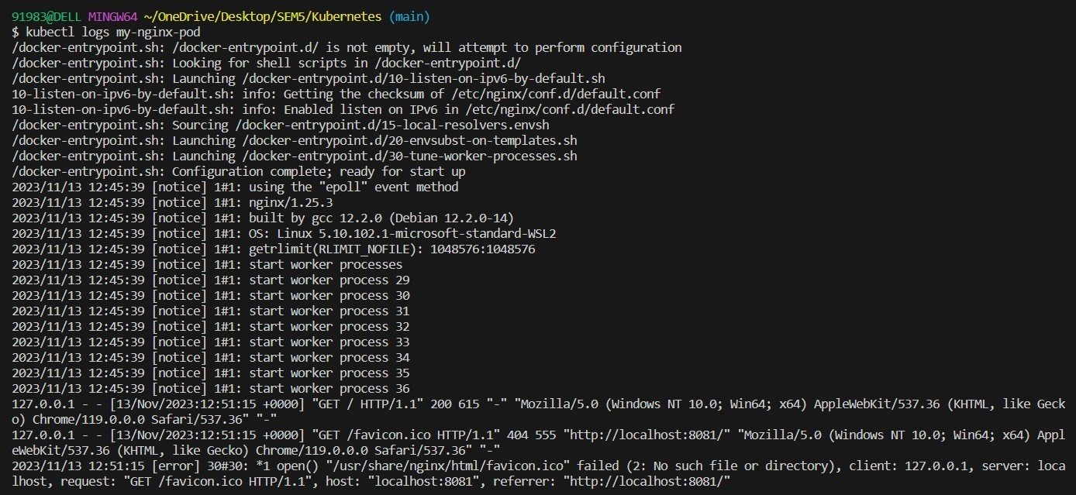

**Task 5: Deleting the Pod**

* + Delete the Pod using the following command:

# “ kubectl delete pod my-nginx-pod ”

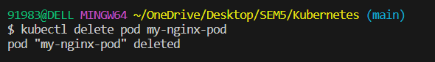

* + Verify that the Pod has been deleted by running the **“kubectl get pods”**

command.

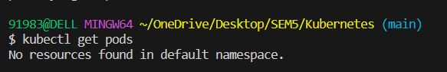

# Task 6: Advanced Pod Configuration

* + Experiment with advanced Pod configuration options such as environment variables, volume mounts, resource limits, and labels.
  + Update the Pod manifest file and apply the changes to the Kubernetes cluster.

# Task 7: Cleanup

Delete any remaining Pods, services, and deployments created during the exercise using the appropriate kubectl delete commands.

# Task 8: Documentation and Best Practices

Document your findings and the best practices for creating and managing Pods in Kubernetes.

Through this exercise, you'll gain a better understanding of how to create, manage, and interact with Pods in Kubernetes. Adjust the exercise based on your specific use case and requirements.